SPHERES Test Plan

for ISS Test Session 35

Smartphone IVA Survey

Setup Items
Qty | Item |  | Qty | Item
1 | SPHERES Satellite |  | 2 | SPHERES Battery Packs
5 | SPHERES Beacons with mounts |  | 1 | SPHERES CO2 Tank
3 | Handrail Extenders |  | 1 | PRIMARY LPTX Antenna
1 | SPHERES Beacon Tester |  | 1 | Expansion Port Cable
1 | Smartphone USB Cable |  | 12 | AA batteries
2 | Smartphones |  |  | Duct tape
Note: If possible, locate the control area (SSC’s) on the PORT side of the JEM.

Test Plan

Group A
Test | Comments | Run Time | Test Result
Program:  35 (1 Sat): Smartphone IVA Survey | Satellite: Red, Primary | 70 min
1. Quick Checkout |  | 1 min
2. IVA Survey | Repeat this test approximately 8 times, or until POIC directs you to stop | ~8 min
Test Session SUCCESS Marker
END OF TEST SESSION

Session Objectives
Test Two, IVA Survey, will demonstrate ground command of the satellite through the Smartphone. The ground controller will conduct video surveys with the Smartphone mounted on the satellite by running several different search patterns in order to locate two targets: a second wall-mounted Smartphone and the IVA Test Target. At the end of each survey search pattern, the SPHERES test will terminate and you will need to restart Test Two so the ground controller can run the next survey.

The ground controller will run about eight surveys. POIC will notify you when you are starting the last test. Pages 3 and 4 of this test plan show the four planned survey patterns. The ground controller is also testing manual control of the SPHERES, so the path of the SPHERES may not match the survey pattern exactly.

Beacon Setup

NOTE 1: This session is being operated in the JPM (JEM) Bays 4 and 5.

NOTE 2: SPHERES Beacon IDs WILL NOT need to be changed. They will remain as follows:

Label on Beacon ID Dial & ID on Beacon Tester (see Work Area Setup 1.001 Fig 4 & 5)
1 1
2 3
3 5
4 7
5 9

NOTE 3: Beacons 1, 2, and 4 require use of a Handrail Extender

View from STBD to PORT (towards airlock)
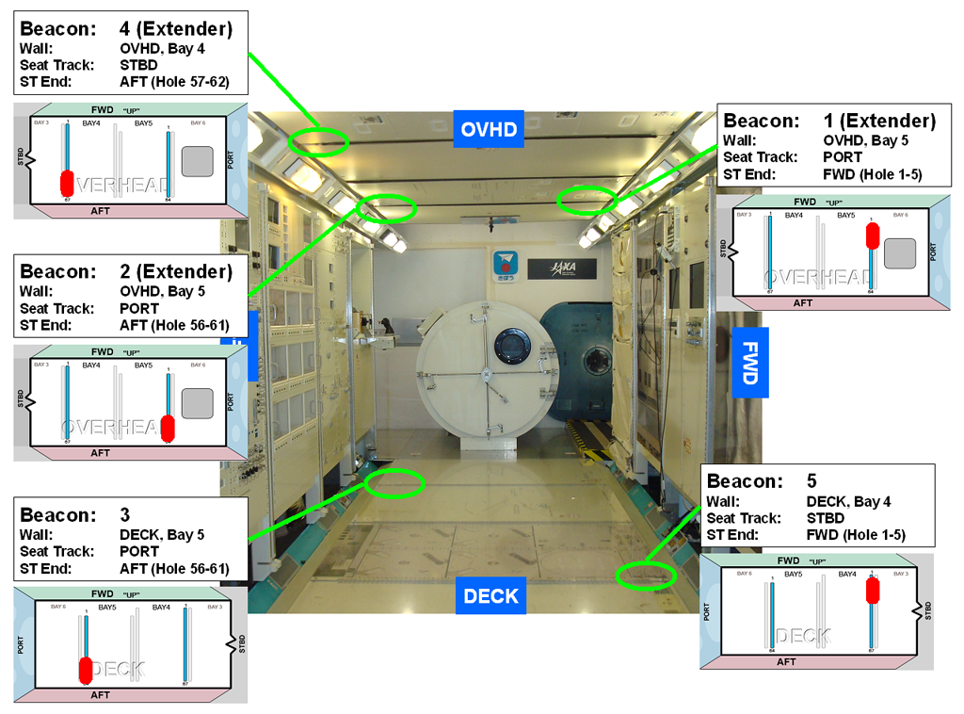

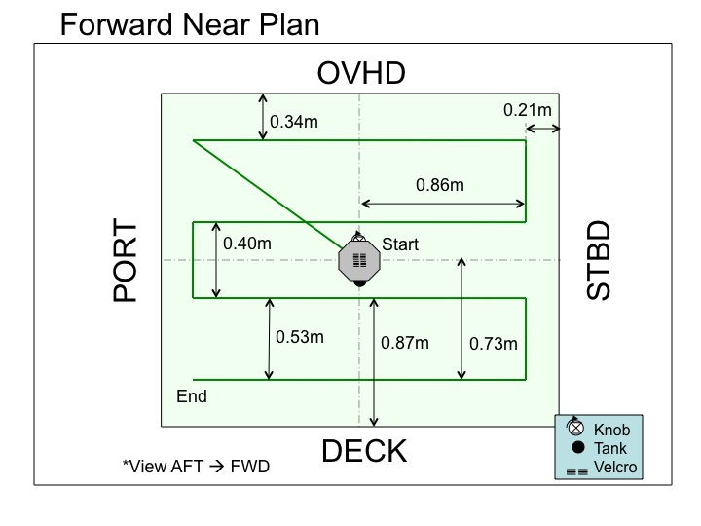
SPHERES will be 0.73m from Forward wall.

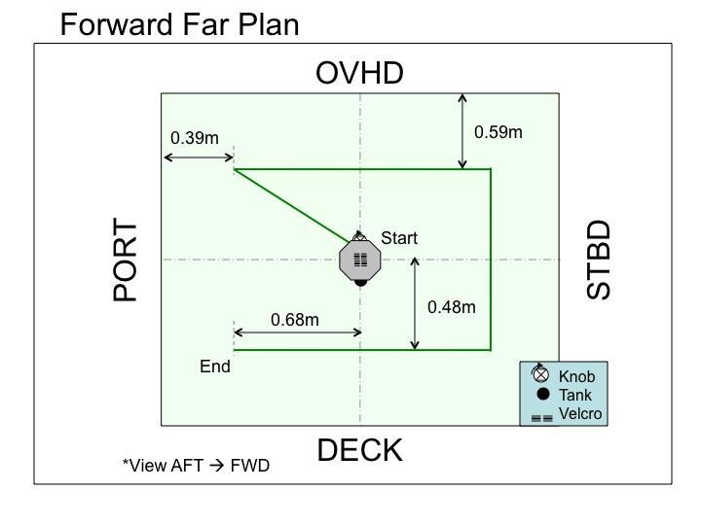
SPHERES will be 1.13m from Forward wall.
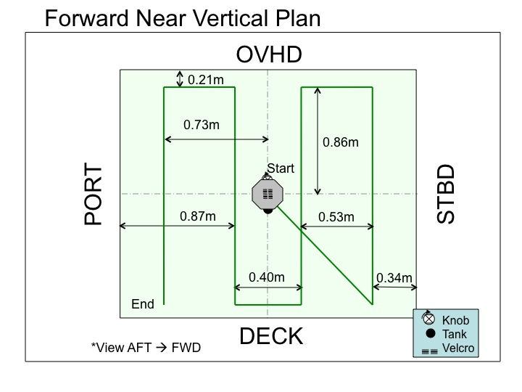
SPHERES will be 0.73m from Forward wall.

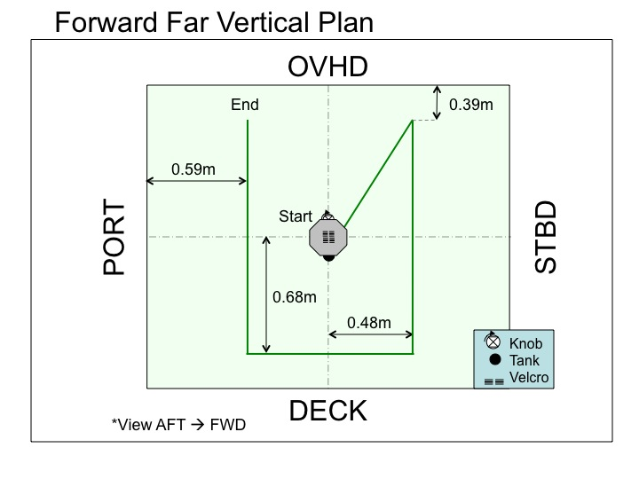
SPHERES will be 1.13m from Forward wall.

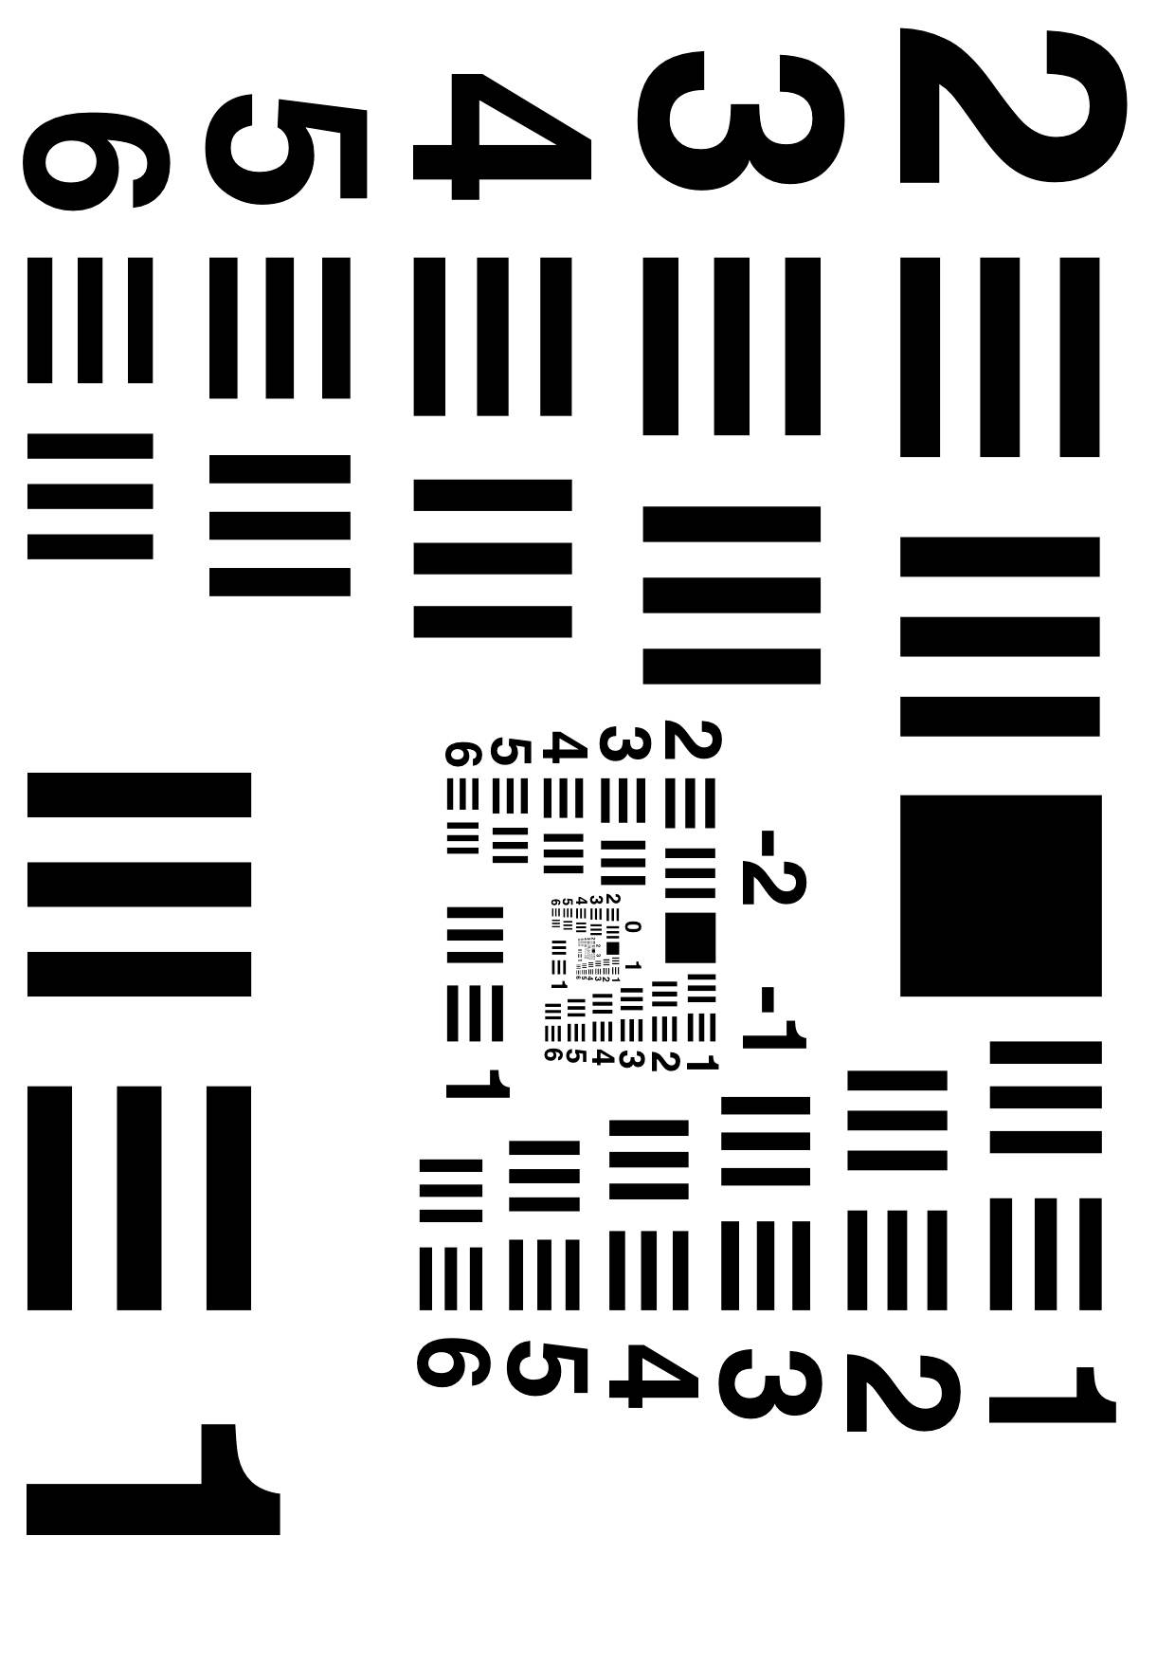
IVA Test Target

I



